**EPQ Artefact Portfolio**

***Introduction***

As part of my EPQ project I have decided to create an artefact to validate my research and, hopefully, prove whether my project title 'The Best Game is Made by the Player' can be seen as a valid statement. The idea that I chose for my EPQ project is based on the player-centric approach of games design and viewing games from the perspective of the potential users being a part of the development team in an abstract way. The main end objective that I am hoping to achieve from this project is to find out how knowing your players from the beginning to the end of the development cycle can influence the success of a video game. My artefact will hopefully help me to analyse this influence as the game I create will be based on a player personality test that I created and evaluated to see what the major player personality types of my potential users fell into and additionally; what genre of game the majority enjoyed playing. The success of my artefact and the influence of knowing my players will be analyzed by a second questionnaire, which will be given to the same participants of my first questionnaire, after they've tested the game I create.

***Method***

To create my game, I will be using a game software development kit called Unreal engine which is a high-level game creation software that works with high level code e.g. Java, C++ and VisualBasic. When it comes to coding my game, I will be using the Blueprints Visual Scripting system in Unreal Engine which is a complete gameplay scripting system based on the concept of using a node-based interface to create gameplay elements from within Unreal Editor. As with many common scripting languages, it is used to define object-oriented classes or objects in the engine.[1] Unreal Engine has been used in the past by professional gaming studios to create many top class, well known games including, [Gears of War 4](https://en.wikipedia.org/wiki/Gears_of_War_4) and Street Fighter V sot truly is an engine deigned to create amazing games.

***Artefact Data Analysis & Game Idea***

Before starting the design and development of my artefact I handed out 25 questionnaires and analyzed the results which would show me the major player type my users fit in and also the genre preferred by the majority. I collected very good results which made it easier for me to know what kind of game I had to design. From the data the genre that was favoured by most of my users (40 %) was action and the next most favourable genre was only preferred by 15 % which is a significant difference, therefore I decided that the genre of the game I create will be action.

The personality type/domain of play that my users were most compatible with (mean average – 67 %, mode average – 70 %, median average – 65 %) was that of conscientiousness/challenge:

* Conscientiousness – “Conscientious individuals are task-focused and orderly, rather than distractible and disorganized.”
* Challenge – “VandenBerghe correlates a desire for challenge — and perhaps more specifically effort and control — with the trait of conscientiousness. High-challenge players prefer games that are difficult and require precision to win. Their conscientiousness drives them to act, to accomplish things, and perhaps to try to complete everything in a game.

I knew that I had to create a game that: had a set task; was difficult; and required precision to win. So ultimately the game I created had to be a challenging action game if I was to explain it in the highest level of abstraction.

When considering that there were also the personalities of openness/novelty and extraversion/stimulation which had a compatibility percentage of over 60 % on average across all the percentages I collected for them, I decided that I would also have to incorporate some experiences into the game which would cater to them personality types.

* Openness to new experiences – “highly open individuals have a broad rather than narrow range of interests, are sensitive rather than indifferent to art and beauty, and prefer novelty to routine.”
* Novelty – “This correlates with the first trait, openness to experience. Players who seek novelty like games that include a lot of variety and unexpected elements.” These players are essentially open to anything as they like the new experiences.
* Extraversion – “Highly extraverted individuals are assertive and sociable, rather than quiet and reserved.”
* Stimulation – “Particularly via social engagement, this naturally correlates with extraversion. These players enjoy party games and others that involve interacting with other players.”

On the other hand, the other two personality type’s agreeableness/harmony and neuroticism/threat had a low level of compatibility so I decided that I wouldn’t integrate them into the game.

* Agreeableness – “Agreeable individuals are cooperative and polite, rather than antagonistic and rude.”
* Harmony – “In this case … VandenBerghe is referring to social harmony and correlates this motivation with the personality trait of agreeableness. He sees cooperative games such as Little Big Planet as good examples of games that offer social harmony.”
* Neuroticism – “Neurotic individuals are prone to experiencing negative emotions, such as anxiety, depression, and irritation, rather than being emotionally resilient.”
* Threat – “This domain is the most peculiar one because players’ reactions to it are the opposite of what you might expect. The game quality of threat (an element of danger, or frightening content—anything that is likely to generate unpleasant emotions) is popular with people who have high neuroticism scores in OCEAN tests.”[2]

After brainstorming many possible ideas for what game I should create, I came to the conclusion to create a first person shooter (fps) as many people in the questionnaire I handed out that chose action as their preferred genre also chose fps which I counted towards action. The fps shoot will be based on shooting enemies which spawn randomly. The aim of the game is to kill as many enemies as you can before the time runs out. I will make the game challenging by having no limit to how many enemies spawn, meaning that the only way the game will send is if you survive the wave of enemies in the amount of time given. The openness/novelty aspect of the game will be smoothly integrated into the game through how the enemies will spawn randomly. This means that each time someone plays the game enemies will come from them in different directions so there will be no way for users to somehow remember patterns to try and remember where the enemies spawn from. The last personality type that I had to include in the game was that of extraversion/stimulation. I thought of making the game with two players as an attempt to stimulate and or simulate social interaction with friends, however this would probably mean that the game would have to become a split screen and could cause complications. As a result, instead I thought of making the game competitive in a sense that players can compete to see who can kill the most enemies in the given time limit. This Concept will stimulate social interaction through competition, making the actual act of playing the game more interesting.

***Design and Development Process***

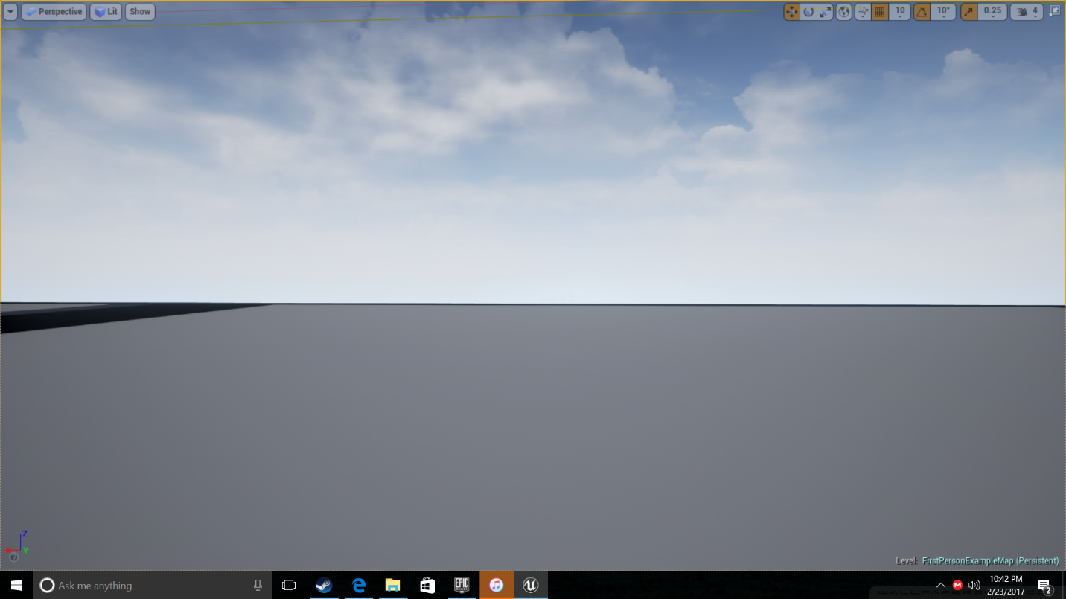

I started by opening a new level on Unreal engine which contains nothing but a starter platform and lighting, the rest of the level is empty.

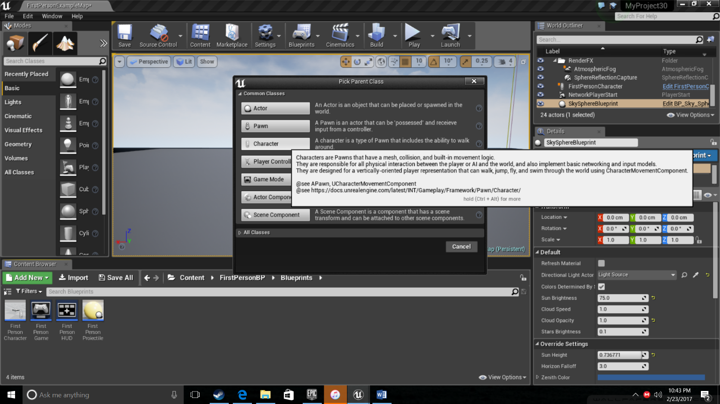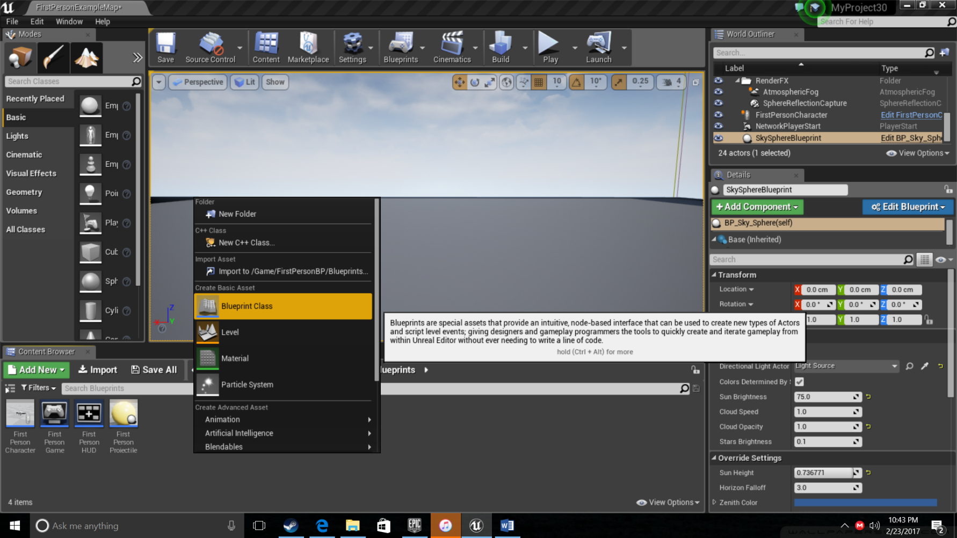***First Person Character Blueprint***

The first asset that I am creating for the game is a blueprint for the character. As I stated in my method I will be using blueprints for my coding which is a type of visual script offered by unreal engine. The reason I’ve decided to use blueprints instead of more traditional code is due to the limited time that I have to finish the game for my project. Blueprints allow me create the same high level content however it takes less time which is more efficient in case.

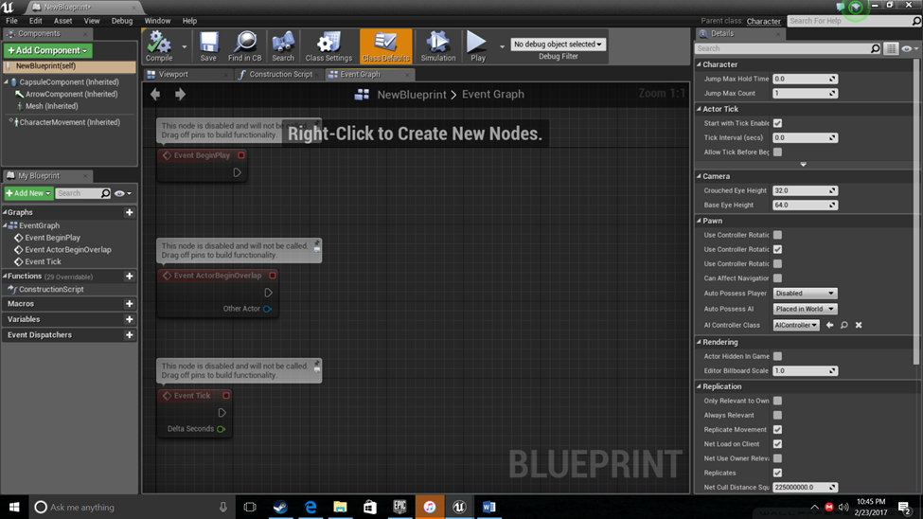

This is the starting interface for a character. This interface is equivalent to the section in an IDE e.g. Visual Studio where you would write your code. The way blueprints work is through the use of nodes d connectors. Nodes are like functions within a program and with blueprints you make links to the nodes you need.

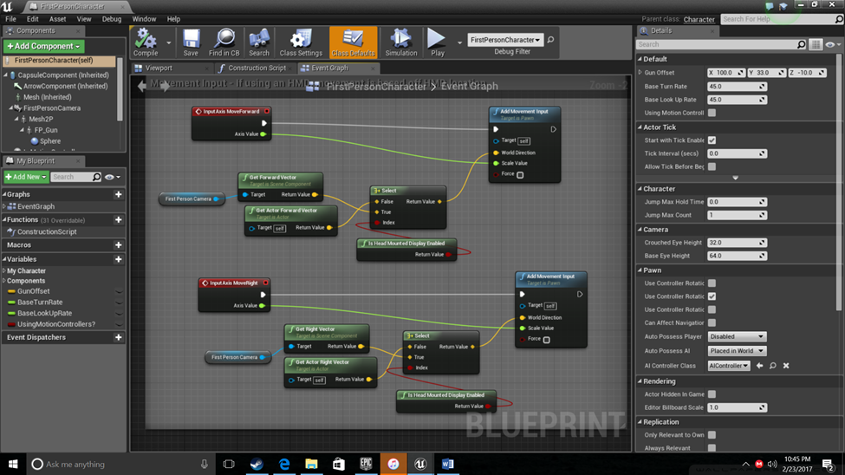

As I said blueprints work with nodes and connectors. In the above screenshot I have used different kinds of nodes and connected them in a way which will allow character movement. the red (InputAxis) nodes receive the data (input from keyboard) and the blue (Movement) nodes change the input data into movement input allowing the player to move in the right direction. The first person camera node is connected to vector nodes which works with the axes in relation to the direction the player is facing and is how the firstperson camera will stay alligned with the right axis during gameplay.

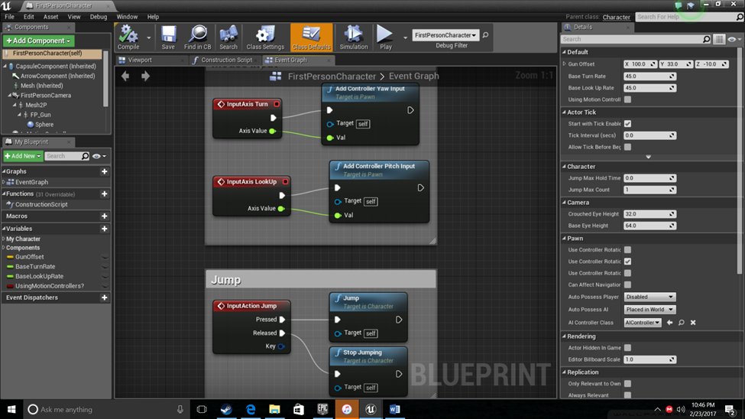

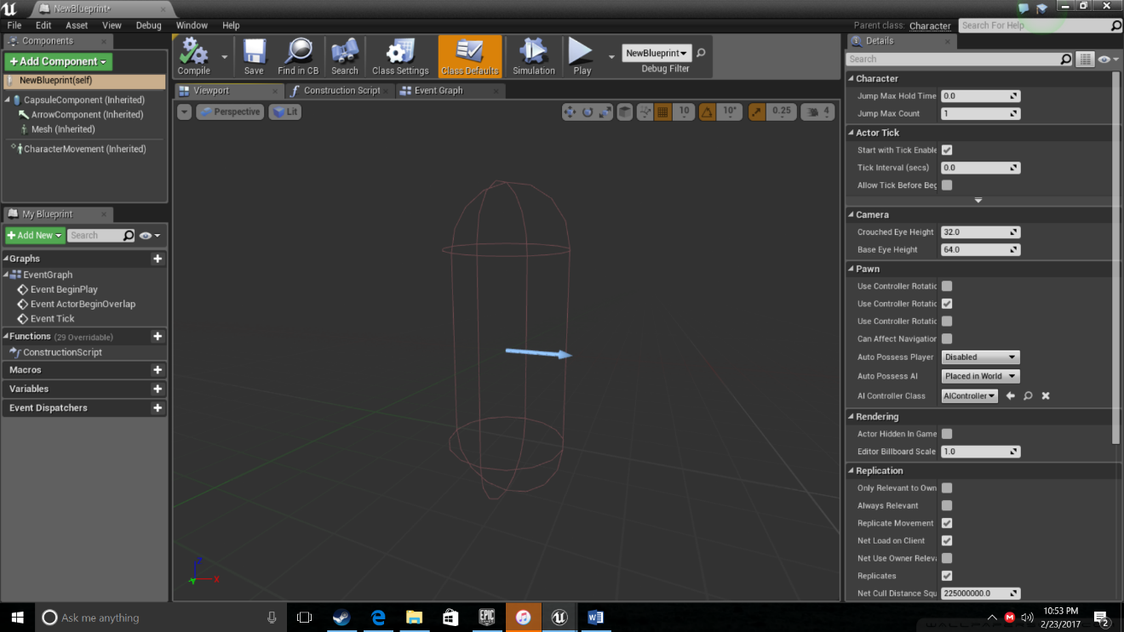The next nodes and connections that I set up receive an input from the keyboard and mouse to allow other ranges of movement. The ‘InputAction’ node is to allow the character to jump from a keyboard input while ‘InpuAxis*’* nodes receive an input from the mouse allowing the character to look around.

This is the actor for the first person character in which I drop my blueprints in for all the movements to work and the first person camera to be activated.

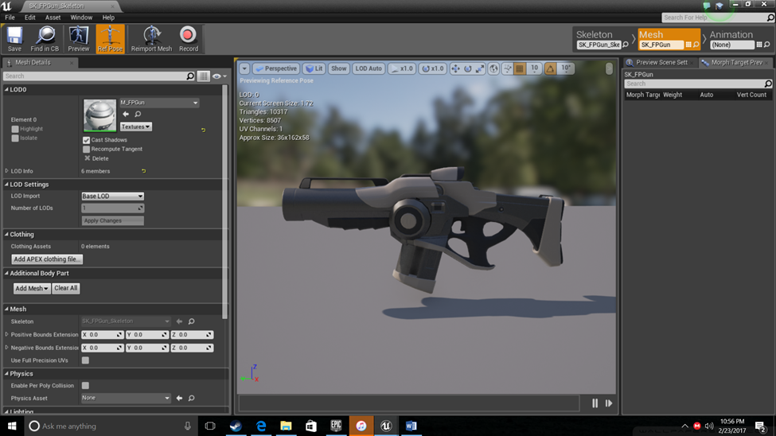***Gun Blueprint***

This is the test gun mesh that I downloaded from the Unreal Engine marketplace and will modify for use in my fps game.

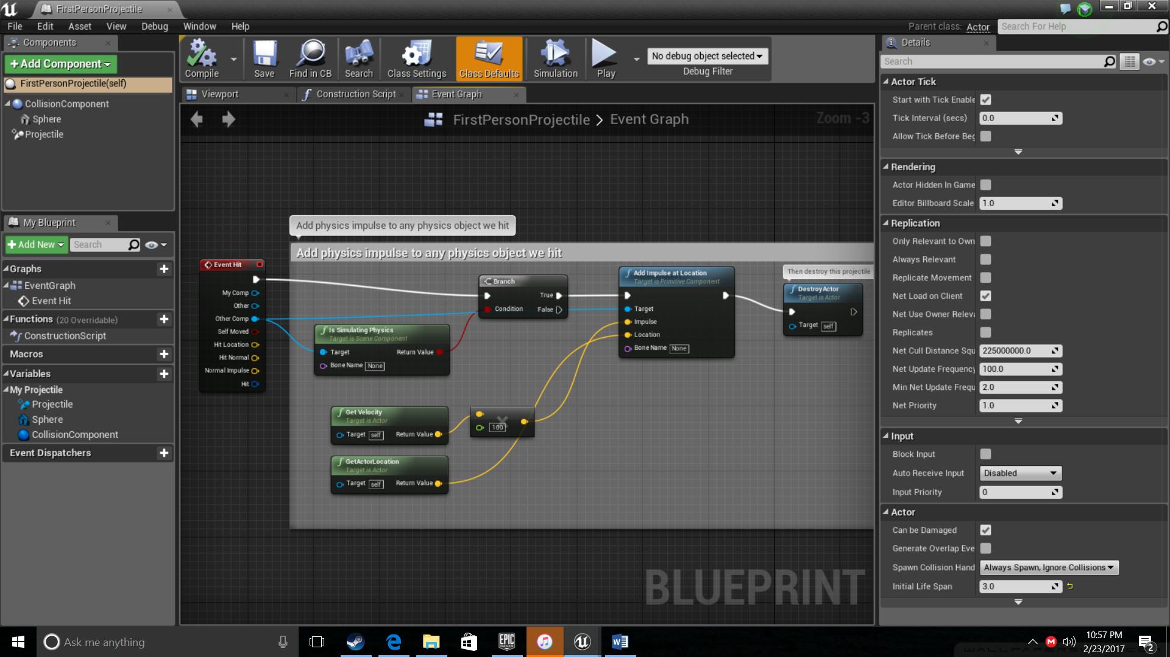

This is the blueprint for the gun which I’ve created to add an impulse to any physical object hit and aslo destry the actor, which is the projectile, on imapct. This gives the gun a realistic effect.

*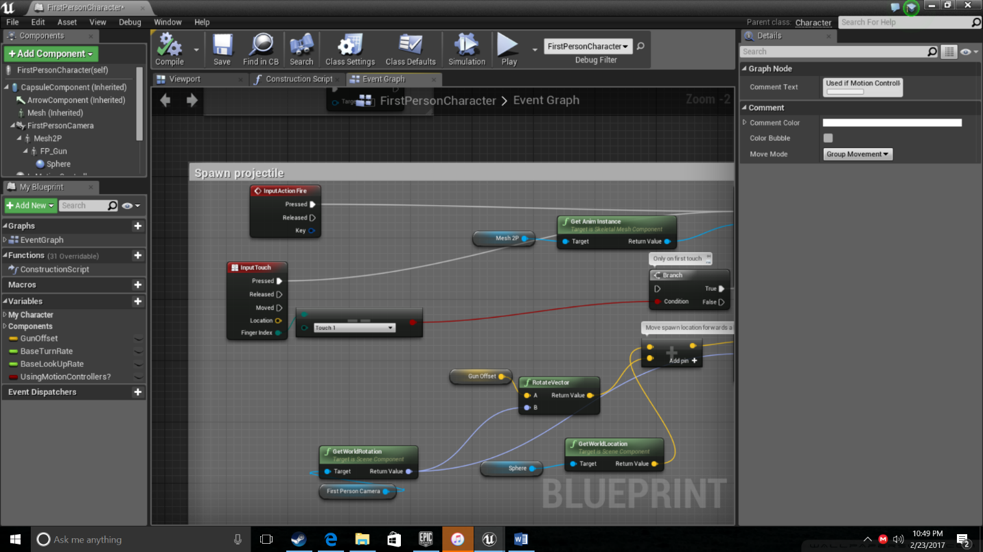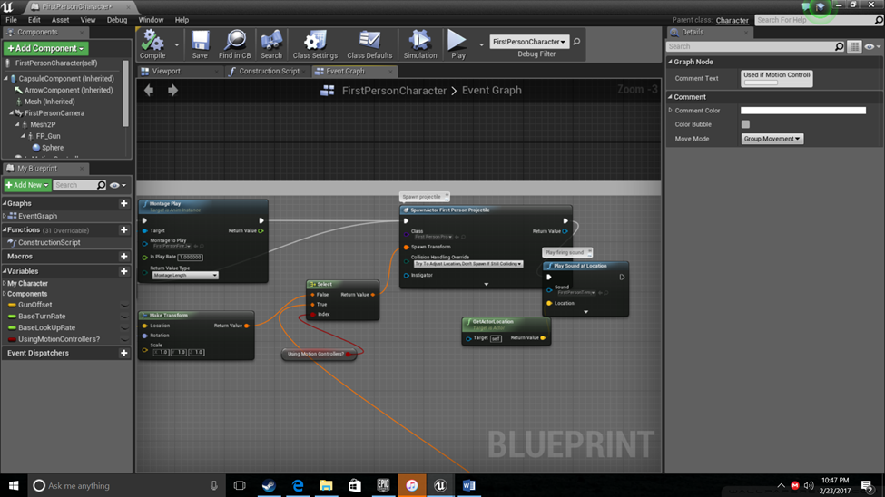****Shooting Blueprint***

The shooting blueprint is quite complicated as there are many things to take into consideration. Firstly I used two input nodes. The node ‘InputTouch’ receives an input from the left mouse click ‘InputAction Fire’ acts as a while loop. This means that while the left mouse button is clicked, a projectile will be fired. The blueprint essentially will move the spawn location of the projectile forward and transform it in front of the gun. As the projectile is formed, the sound of the gun firing will be played.

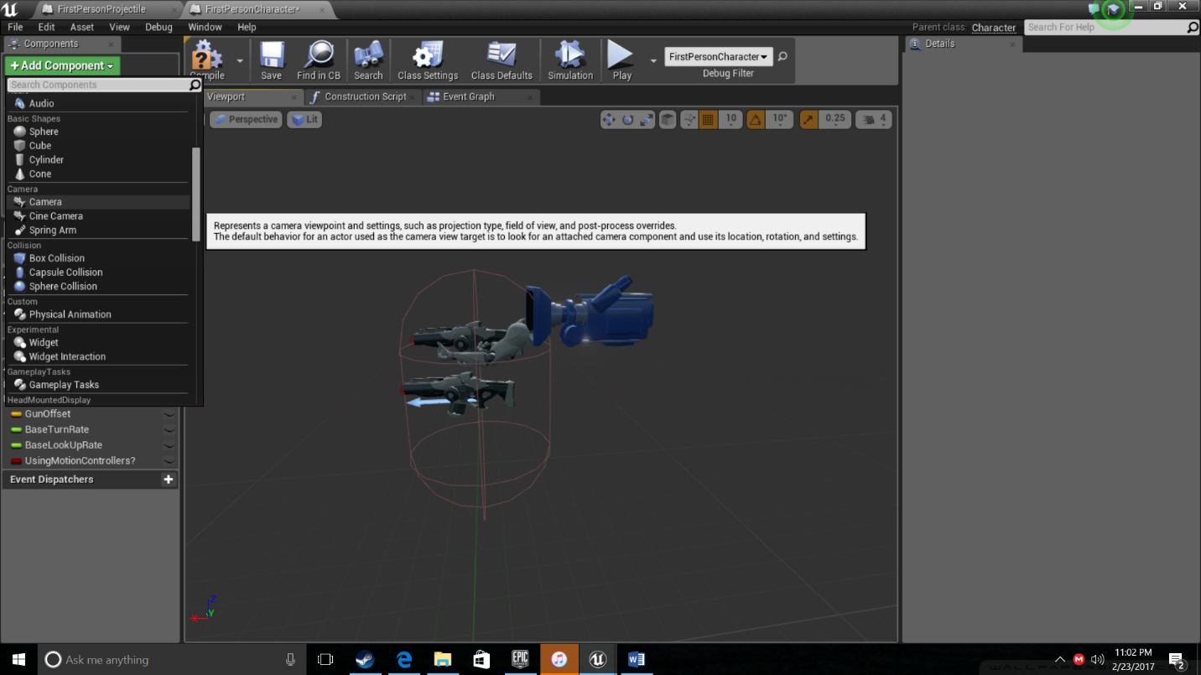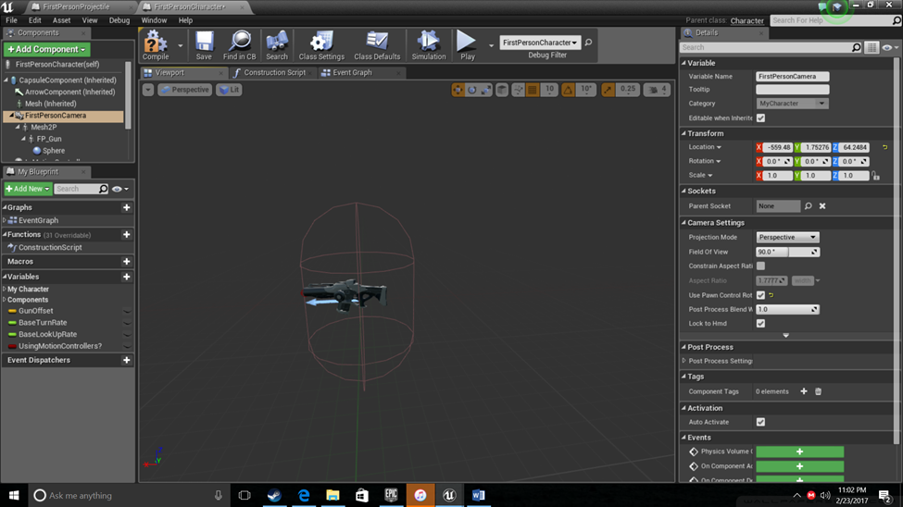

In the components tab I add the gun to the character and I also add a camera which will be used for the view target, location, rotation and settings.

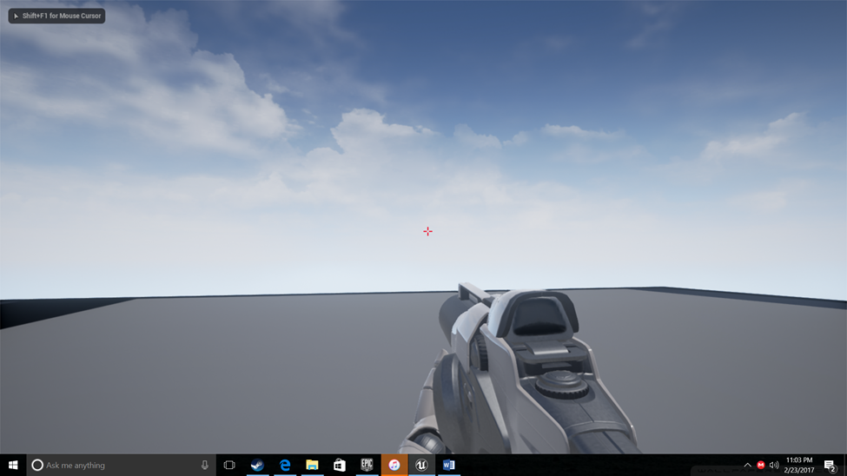

This is now what happens when I press the play button

***Enemy AI Blueprint***

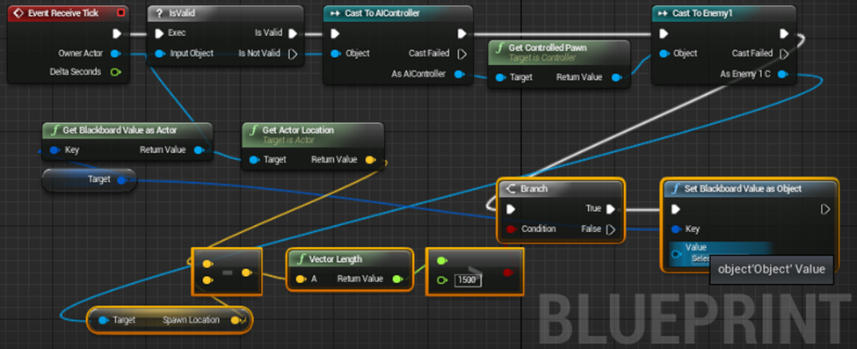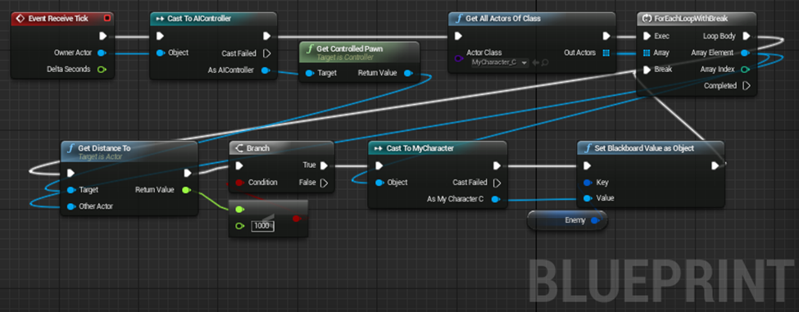

This is the blueprint for enemy AI, when the character gets within a range then the AI will begin to shoot or try to chase the character. The basis of this working is through essentially using events and location vectors, so when the location vector is within a certain range of the AI then the event is true and the AI will target the character. I will add this blueprint to an enemy character and when the enemy is shot it dies however they always respawn.

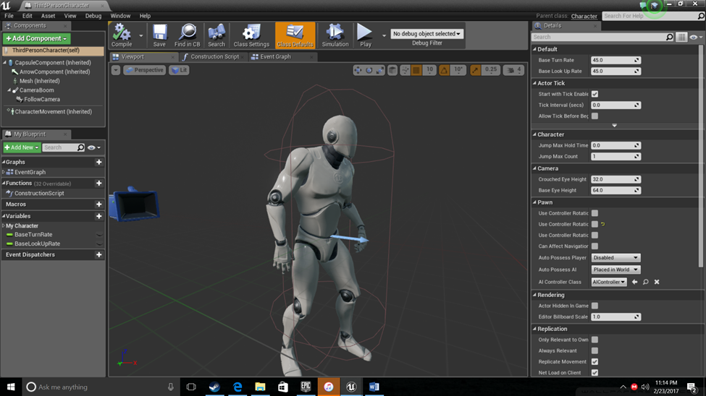

*I downloaded this character as a test for my enemy and applied the blueprint to it.*

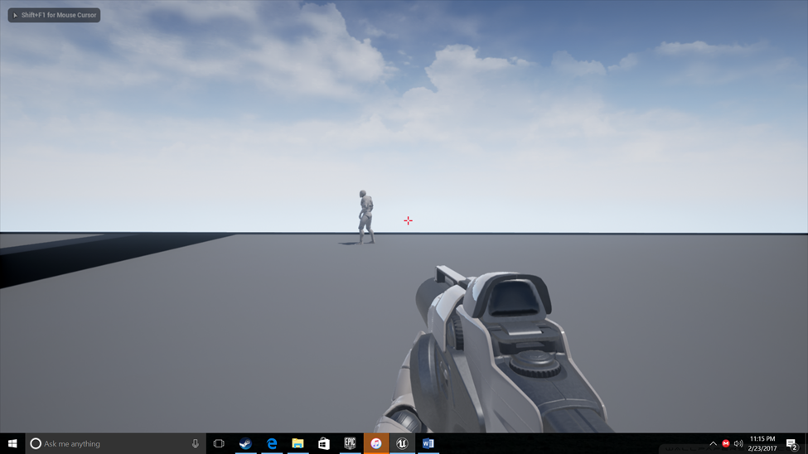

I added the enemy character to the map and it is able to interact and attack whenever my character gets up close and I added the gun to him through the components tab.

***Designing the Map***

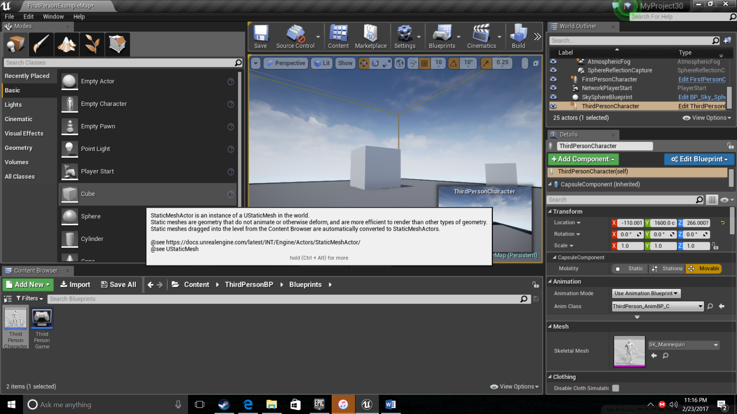

I will be building my map using cubes as I can resize them in many ways to make obstacles/paths and also add my own texture to the cubes to give different feels depending on what kind of atmosphere I want for the game.

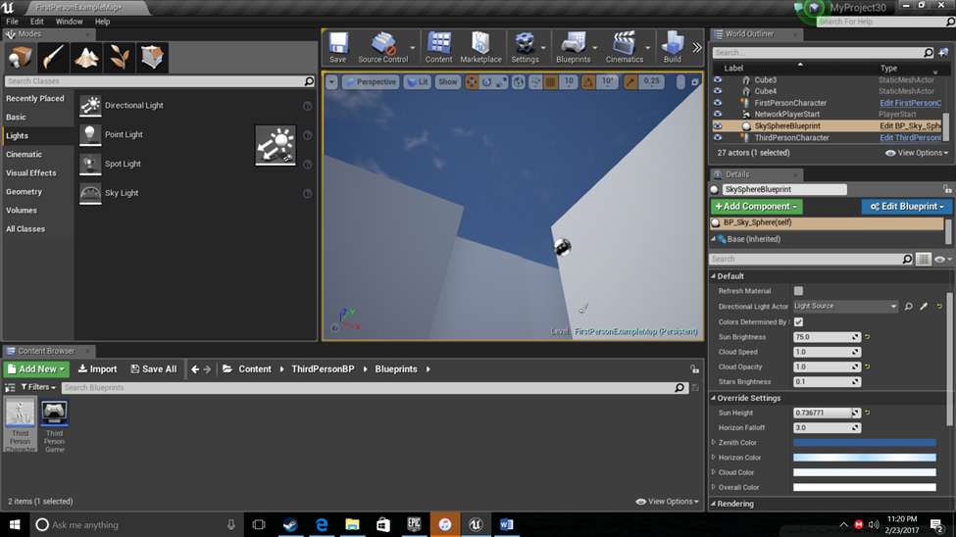

As I enclose the map, I add lighting using point lights for the build menu.

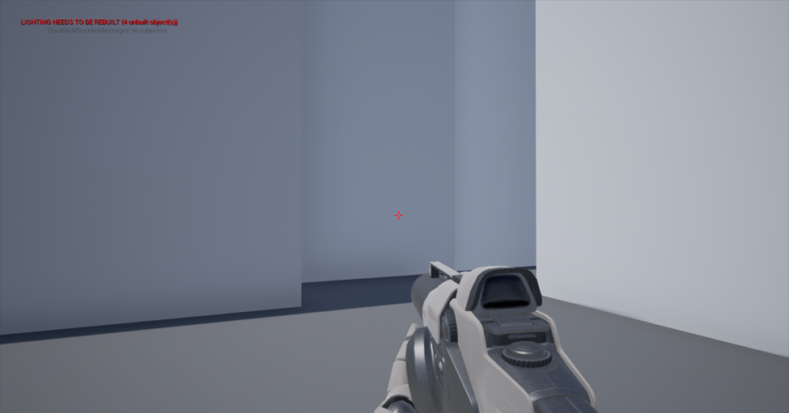

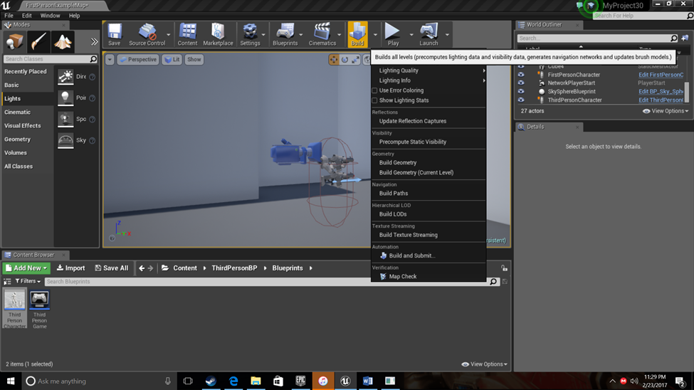

As I continue to place cubes around the map I have to rebuild the project and lighting to fix an invalidation cause by moving and adding new objects to the map.

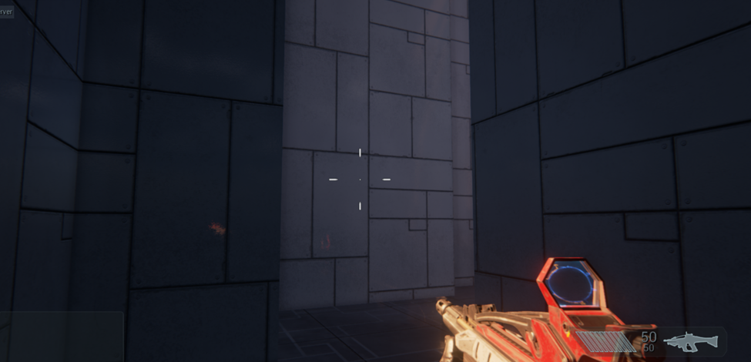 Now I’ve placed all the cubes where I want them, I changed the texture of the cubes and rearranged a few to give a futuristic enclosed space look and feel to the game. I downloaded a new gun mesh from the market place which looks a lot more technical and high-tech to match the futuristic look.

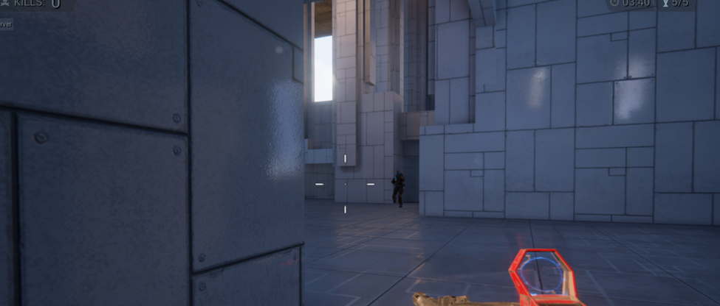

I’ve also finished modifying the enemies so the run at you and try to attack you.

1. <https://docs.unrealengine.com/latest/INT/Engine/Blueprints/> (accessed 14th February 2017)
2. Adams, E. (2013) Fundamentals of Games Design Third Edition. Published by New Riders, United States of America.